Fong, S., Ho, L., Chew, L. S., Wong, K. W., Wee, S., & Jacobs, G. M. (2000). Introducing cooperative learning to P1 and P2 pupils. Teaching English Language and Literature (Singapore), 16(1), 3-8.

Introducing Cooperative Learning to P1 and P2 Students

Mrs Salim Fong, Mrs Linda Ho, Ms Chew Lay See, Mrs Wong Kok Wah
Mayflower Primary School
Sheila Wee
Teachers Network
George M Jacobs
SEAMEO Regional Language Centre

Background
It was scary at first. Just getting P1 and 2 students to follow basic instructions is hard enough; trying to get them to work together in groups seemed like asking for extra trouble. But, a dash or two of trouble adds a bit of spice to a veteran teacher's life; so the four of us teachers at Mayflower Primary School - a neighbourhood school in Ang Mo Kio - decided to take up the challenge when our principal, Ms Ngeow Ah Cheng, asked if we'd like to join a Learning Circle to help us use cooperative learning with our lower primary students. This article recounts our odyssey. We begin with a little background on cooperative learning and Learning Circles.
Cooperative learning (CL) can be defined as concepts and strategies for helping students work well with one another. In other words, CL is a lot more than just telling students to "work together". Learning Circles (LC) are a form of teacher-directed professional development. Through LCs, we teachers work together to: reflect on the how, what, and why of our teaching; identify and solve problems in our teaching; and share our insights with fellow professionals. So, you could say that LCs are a form of CL among teachers, but LCs don't have to be about CL. Other LCs in Singapore deal with issues such as helping underachievers, environmental education, and teaching thinking. In Singapore, MOE's Teachers' Network is a prime breeding ground for LCs. They supplied us with a friendly facilitator, Sheila, and a not-so-friendly, but charming nonetheless, resource person, George.

Laying the Groundwork

When most people think of CL, they think of students working in groups of four or less, but to get CL to work we started at the whole-class level. Establishing good classroom management from day 1 of the new school year helped us prepare our P1 students to behave appropriately in groups. Our procedures included:

1. We teach students an attention signal. Not all of us use the same signal, but one signal that usually works is the RSPA signal -
a. Raise hand - when students see Teacher's hand raised, they raise their hands.
b. Silence - when students raise their hands, they bring their conversations to a close.
c. Pass the signal - students pass the signal to their classmates who are working so enthusiastically that they did not see Teacher's hand raised by tapping them on the shoulder or whispering to them.
d. Attention to the Teacher - students stop whatever they are doing (put their pens down, take their fingers off the keyboard), look at, and listen to Teacher.

[Here we can insert the photos of the children doing RSPA. It might be nice to add a photo of them Passing the Signal]

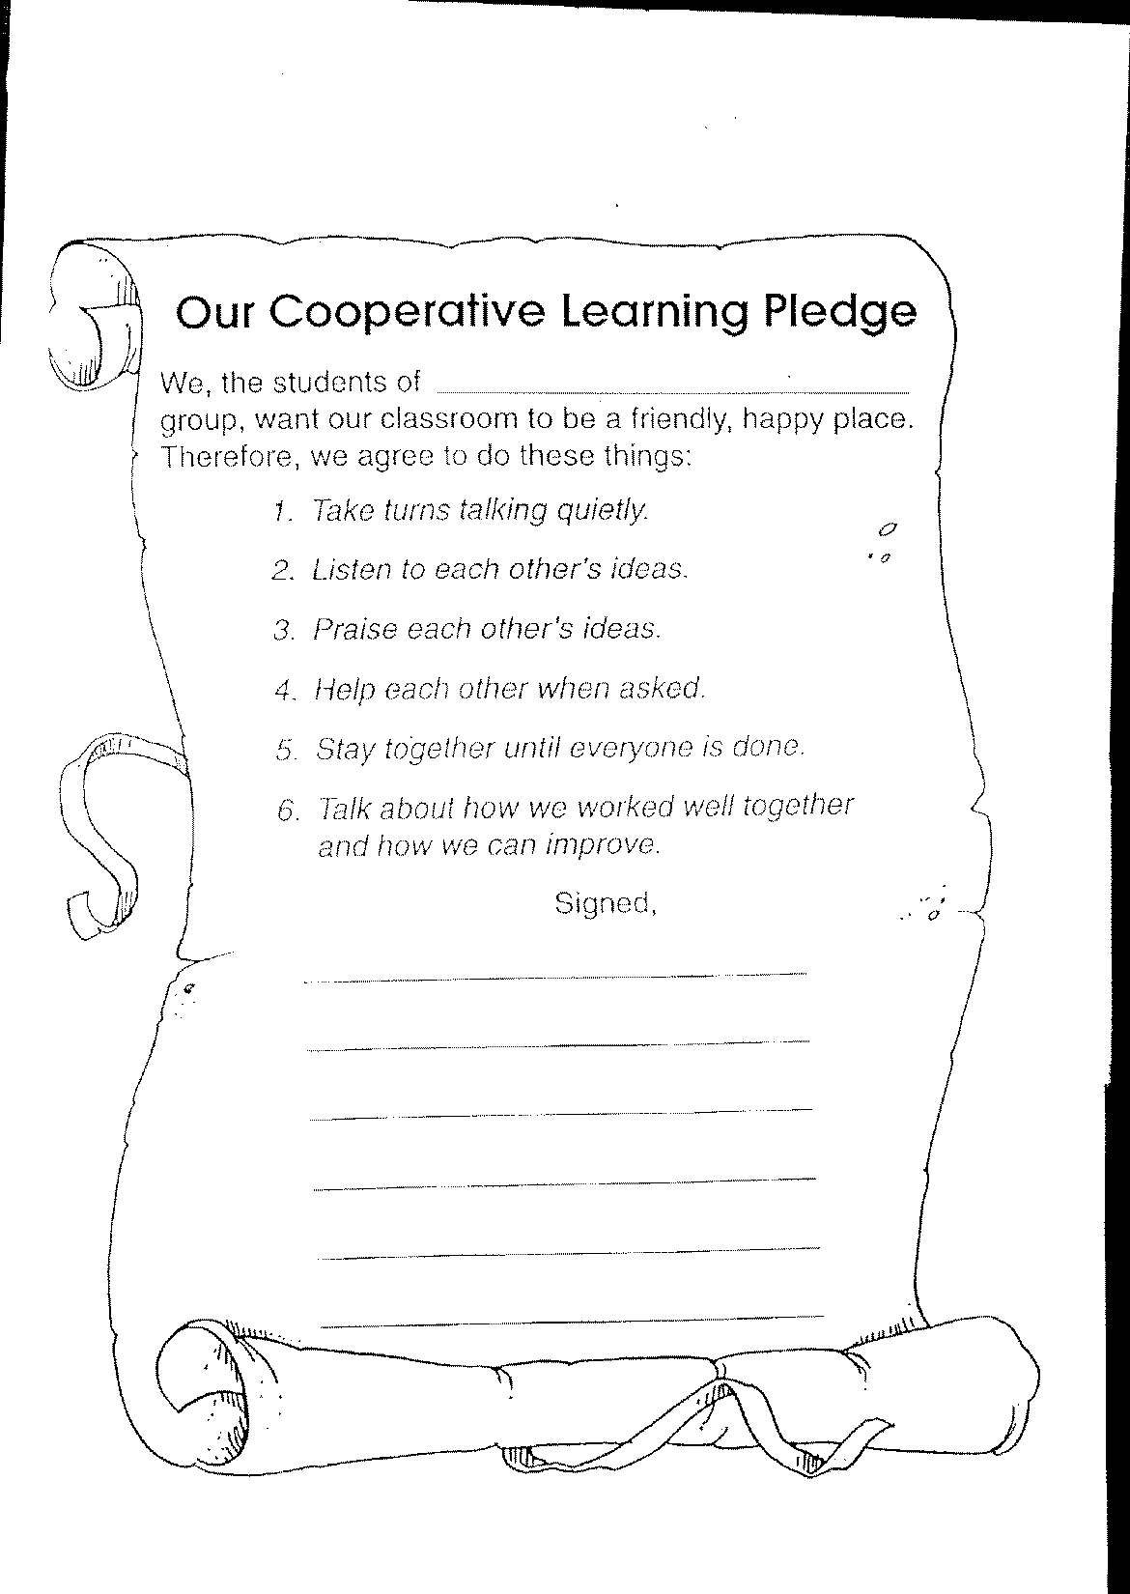
One thing that helps make RSPA successful at Mayflower is that we have a whole-school approach, with Ms Ngeow and our VP, Mr Wong Kong Chiew also using RSPA with the children at assembly and USSR time.

2. We set up class rules

Students cannot get down to the serious business of learning unless they feel secure in the classroom. Part of students feeling secure is knowing from the beginning how they are expected to behave and work in a classroom environment. They want instructions and guidance on all the “how-to’s”. Hence class rules are necessary for an effective classroom. We involve students in the setting up of class rules. This is how we can approach it:
- Brainstorm rules for proper behaviour. Define the resulting rules and discuss the “can” and “can’t” of the rules.
- Select the 6 most important rules and rehearse them with students.
- Guide and coach the students through practice and through immediate, specific praise for correct usage and immediate notification of lack of use.

These rules can be posted on the wall or made in a class pledge as seen below.

One of us encouraged good behaviour via group names. First, the class generated adjectives related to being good, such as friendly, brave, and helpful. The teacher wrote these words on cards. Each group leader (this was a rotating role) selected a card, and the adjective on the card became their group’s name. Periodically, the leader would ask group members if they were being friendly (e.g., by greeting group members and asking how they were), brave (e.g., by asking questions when they did not understand), or helpful (e.g., by offering to assist group members who were having difficulties).

One point that we'd like to stress is that good classroom management is not built in a day. It takes persistence. We have to "waste time to gain time". For instance, we did not just show students the RSPA signal once. We showed it to them, we explained why it was important, we had them practice it, and we insisted on it being done properly. Sometimes, after a few weeks, children may started to slip, e.g., RSPA wasn’t working so well. We didn’t give up. Instead we reminded students of why these behaviours are so important and encouraged them to encourage each other to use them. Another example of the power of persistence is that it took two weeks before students were taking turns, and even now, they sometimes get excited and forget.

Teaching Collaborative Skills

P1 students don’t arrive in January killed at academic collaboration; so, we taught students the collaborative skills needed to make CL a success. We worked on one collaborative skill at a time, focusing on it for a couple of weeks. One of the strategies we used to do this is called a t-chart, because it looks like the letter ‘t’. On one side of the t, students say what the skill sounds like, i.e., the words we use. On the other side, students generate ideas for what the skill looks like, i.e., the facial expressions, posture, and gestures that show the skill. Here’s an example of a t-chart for the collaborative skill of Listening Attentively.

Listening Attentively

Sounds Like | Looks Like
asking questions | nodding head
‘yes’ | eyes on speaker
‘uh-huh’ | taking down notes
‘right’ | looking serious
paraphrasing | leaning slightly towards speaker

Another essential collaborative skill, especially for lower primary students, is speaking quietly. Here are four ideas we came up with:

- Teach students to use their soft voices
- Put a noise gauge on the board [picture or drawing of this] which the teacher adjusts according to the class noise level
- Place a laminated picture of the Quiet Captain at the front of the class and use it to remind students when they get too noisy. When we had to leave the room, the student we put in charge of the class also used this.
- Have each group select a noise monitor (or Quiet Captain) who encourages everyone to use their soft voices and who looks to see if the noise gauge is still in the acceptable range.

At first, we called soft voices ‘15cm’ voices to represent the maximum distance over which their voices could be heard, but some students could not conceptualize what 15cm meant. One even said he was going to use a 15km voice! So, we also used the term ‘one handspan’ voices.

We found that the teacher had to set an example of good collaborative skills for the class. For instance, when we spoke to one group of students, we also used soft voices. Another example of us modeling collaborative skills was that we couldn’t ask our students to take turns if we interrupted them when they were speaking.

CL Strategies

Fellow educators have invented many CL strategies, and more are being created, as CL blends with other educational innovations, such as multiple intelligences and IT. Books on CL offer a way to find out about these strategies, each of which has its own areas of usefulness. This is one way our resource person came in handy, as many such books are available at the RELC Library (free to all MOE teachers).

We started with simple CL strategies, such as Think-Pair-Share and RoundRobin. First, we will explain these two strategies and then show you how we combined them in a writing lesson. In Think-Pair-Share, students are in pairs. The teacher asks a question or gives a problem. Each person Thinks alone. Then, they Pair with their partners to discuss their responses. Finally, the teacher calls on some students to Share their partner’s response with the rest of the class. In RoundRobin, each group member takes a turn to speak, one at a time, going around the group.

Both these strategies have several advantages. First, one member per group is speaking. When the teacher leads the class, only one person, usually the teacher, speaks at a time. Thus, when group activities such as Think-Pair-Share and RoundRobin are used, students get a lot more speaking practice. Also, these strategies encourage all group members to actively participate. For instance, in RoundRobin, each person has a designated opportunity to speak. One more advantage is that speaking in groups is less threatening to students than having to speak in front of the teacher and the rest of the class.

Source: Pr.1 PETS, Unit 2

Theme: My Family

Task: Shared Writing

Pre-Activity: Pupils talk to their family members to find out information about them and to collect at least one family photo.

Step 1: Watch the Chatterbox video entitled, “Rosie’s Family”, about the family of a puppet.

Step 2: Think-Pair-Share. Teacher asks students questions about their families. Each student individually thinks of the answers and then shares them with a partner. Next, the teacher calls on a student to share their partner’s answers and to show the partner’s family photograph. The teacher works with the class to convert the student’s answers into a Class Dictated Story (CDS), told in the third-person.

Step 3: Each group selects one member’s photo and constructs a composition similar to the CDS. They do the writing using RoundRobin. Each member contributes one sentence, and they take turns writing down what their groupmate said. Afterwards, they check their story to see that it has all the parts and language features of the CDS.

Step 4: Each group’s leader reads their group’s story to the whole class. Class feedback follows.

Step 5: Each student works alone to write a first-person story entitled, “My Family”.

Evaluation in CL

An important way of encouraging effective collaboration in the groups is to include collaboration as part of evaluation. Students often took part in this evaluation in order to make them more conscious of how they and their group members were behaving. Three ways of evaluating collaboration are:

- Self-evaluation
- Group evaluation
- Teacher evaluation

Individual self-evaluation

After completing a task or in the middle of a task, the teacher would give out an individual self-evaluation form. Students coloured the correct faces and then discussed the reasons for their choices. Below is one instrument we used for self-evaluation.

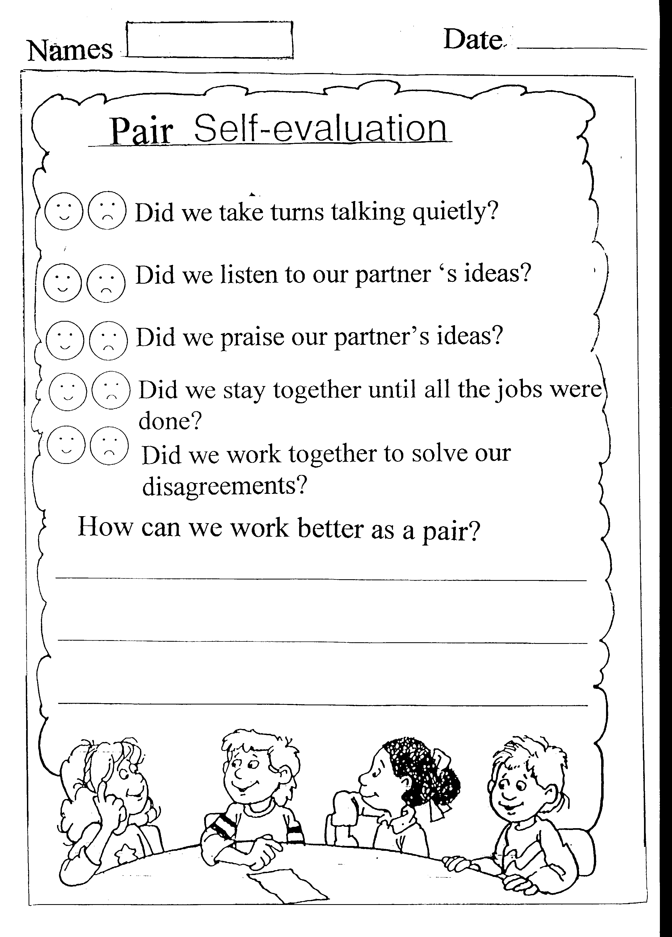

Group evaluation

Students also evaluated collaboration in their groups. These could be groups of two, as in Think-Pair-Share or groups of four as in RoundTable. Students coloured the appropriate face, as they did with the self evaluation instrument. Sometimes students disagreed. We were happy to see this, because disagreement can lead to deeper thinking if students use reasons, not harsh words, to try to attempt to convince one another. Here is one instrument students used to evaluate their collaboration. This one was used for a pair. Keeping groups small makes them easier for students to manage.

Teacher Evaluation

While students are working, the teacher walks around observing:

- Are students following the correct procedure or a reasonable variant thereof?
- Do students understand the content?
- Are group working well together?

Based on this observation, we gave students feedback. Sometimes, we stopped the class in the middle of an activity to point out one group that was working particularly well, highlighting the skills they were suing to do this. Other times, we would stop the class to suggest how they could be more collaborative. We also occasionally used an evaluation form. Below is one of them. Note that it says, “I saw”. We cannot be observing every group all the time. All we can do is record what we saw at the particular time we were observing a particular group. Maybe, the group was doing something great when we were not there. That would be nice.

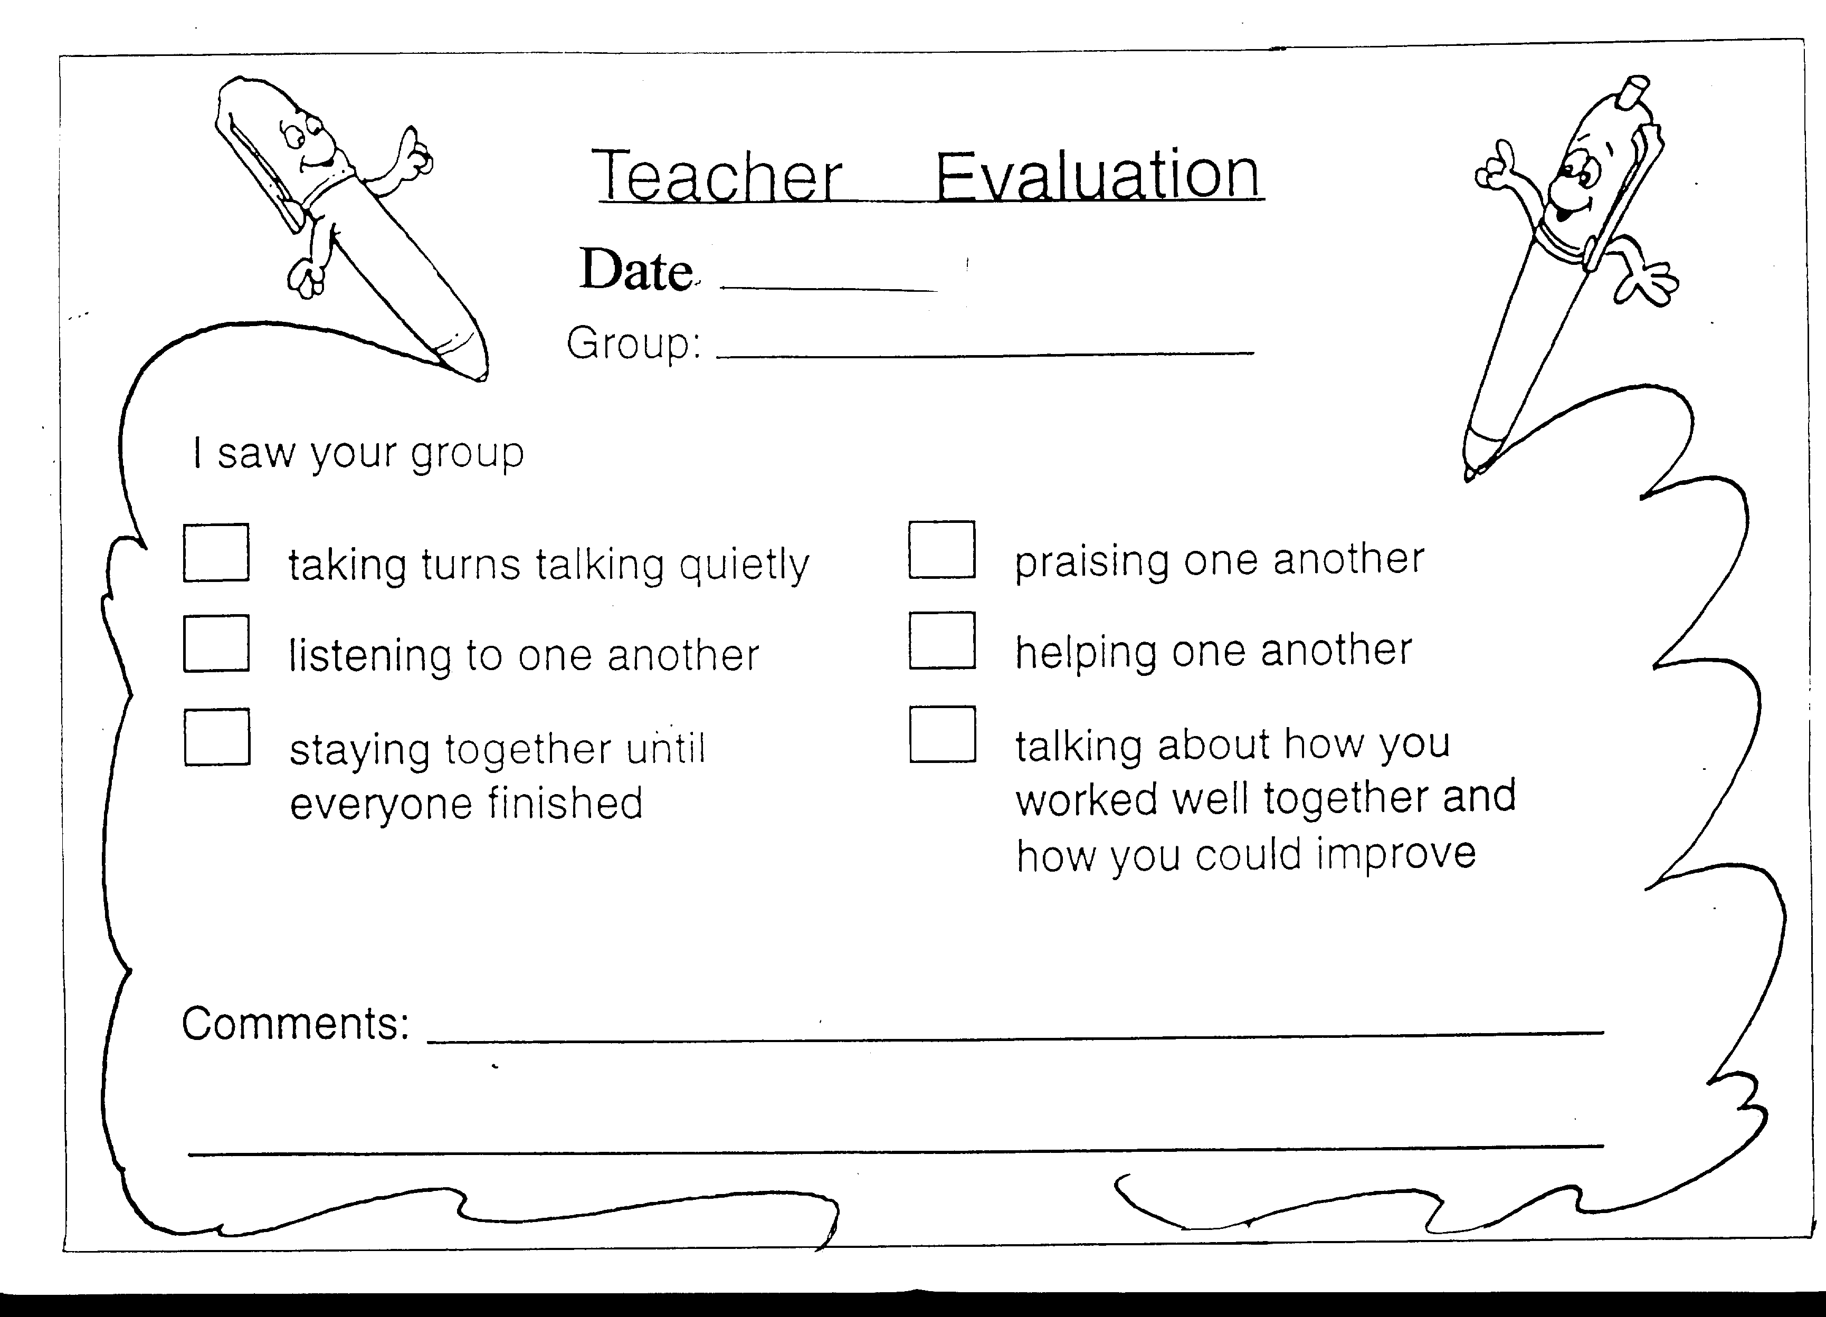

Benefits of Using CL

We've found many benefits from using CL.

1. Students are more daring about asking questions. Perhaps this occurs because they feel less worried about asking the groupmates than asking Teacher. If none of their groupmates know the answer, they don't feel so shy about raising the hand and asking the teacher in front of the whole class, since it's not just they (the one student) who doesn't understand but their whole group.

2. Students are more on task, perhaps because they feel that if they try they can succeed. When working alone, students who don't understand are likely to give up and even misbehave, but in groups they can get help from their partners; so, they are likely to keep trying.

3. Motivation increases:
- Students want to succeed not just for themselves but for their groupmates as well.
b. Students like the class better, are more interested in the subject and each other, and are more self-disciplined.

4. We enjoy teaching more

a. It's exciting to see the students engaged in learning.
b. We don't need to talk as much anymore; so, our throats don’t feel as sore at the end of day.

Benefits of the LC

As every MOE teacher knows, Singapore suffers from no shortage of new ideas in education. The information age has brought forth a new disease "Information Fatigue". For Singapore teachers this disease comes in a special form "Innovation Fatigue", with so many workshops and courses to attend, each turning us this way and that till we we’re dizzy. The LC gave us a place to get a grasp on one key innovation: CL. We had attended workshops by George and others on CL; the LC gave us support for implementing all the information we got at the workshops. We could share ideas and get support, as we built rapport over tea and cakes. At the same time, the LC also gave us pressure, because we knew Sheila would be coming for our twice-monthly meeting at which time each of us had to report if we had done what we had promised at the last meeting and how it had gone.

The LC made us more conscious of what we were doing in our teaching and why we were doing it. Our discussions helped us be more systematic. We came to speak a common language. For instance, now when one of us mentions Numbered Heads Together or positive interdependence, it’s not jargon; we all understand. Also, Sheila and George benefited from working with us. LCs are new in Singapore, so everyone needs to learn what they are about. Also, our hands-on experience with our young students helped bring alive the CL concepts and strategies that Sheila and George like to go on about.

Conclusion

Please don’t think we’re saying that if you use CL all your students will graduate from Cambridge by age 12, or that if you take part in an LC all your colleagues will love you. We still face lots of frustrations with our students. What we are saying is that CL, if implemented carefully, consistently, and conscientiously, can make the classroom a more enjoyable and successful place to be for students and teachers, and that LCs can help us reach new heights as reflective and collaborative professionals.

